EX No:1A | SETTING UP PYTHON ENVIRONMENT AND LIBRARIES – JUPYTER NOTEBOOK

Aim:

To install Python, configure Jupyter Notebook, understand the notebook environment, execute Python programs, create Markdown cells, and use basic Jupyter Notebook features for Data Analytics applications.

Algorithm:
Algorithm 1: Installing Python
- Download Python from python.org
- Run the installer
- Select "Add Python to PATH"
- Click Install Now
- Verify installation using: python --version
- Observe installed Python version

Algorithm 2: Installing Jupyter Notebook
- Open Command Prompt
- Install Jupyter pip install notebook
- Launch Jupyter Notebook jupyter notebook
- Browser automatically opens Notebook Dashboard.

Algorithm 3: Creating a Notebook
- Open Jupyter Dashboard
- Select New → Python 3
- Create Notebook
- Rename Notebook
- Create Code and Markdown Cells
- Execute cells using Shift + Enter

Program:
Program 1 — Simple Python Program print("Welcome to Data Analytics Lab") Output: Welcome to Data Analytics Lab

Program 2 — Arithmetic Operations
a = 20
b = 10
print("Addition =", a + b) print("Subtraction =", a - b) print("Multiplication =", a * b) print("Division
=", a / b) Output:
Addition = 30
Subtraction = 10
Multiplication = 200
Division = 2.0

Program 3 — Display Student Details
name = "John" dept = "AI&DS"
cgpa = 8.9 print("Name:", name)

print("Department:", dept) print("CGPA:", cgpa) Output:
Name: John Department:
AI&DS CGPA:
8.9

Program 4 — Creating Markdown Cell

Data Analytics Lab ## Experiment 1 ### Jupyter
Notebook Then press
Shift + Enter.

Program 5 — Using NumPy Library
import numpy as np
a = np.array([10, 20, 30, 40, 50])
print(a)
print("Mean =", np.mean(a))
print("Sum =", np.sum(a))

Output:
[10 20 30 40 50]
Mean = 30.0
Sum = 150

Program 6 — Using Pandas Library
import pandas as pd data = {
'Name': ['John', 'David',
'Alex'], 'Marks': [85, 90, 95]
}
df = pd.DataFrame(data)

Program 7 — Using Matplotlib Library

import matplotlib.pyplot as plt x = [1, 2, 3, 4, 5]
y = [10, 20, 15, 25, 30]
plt.plot(x, y) plt.title("Sample Line Graph") plt.xlabel("X Axis") plt.ylabel("Y
Axis") plt.show()

Output:
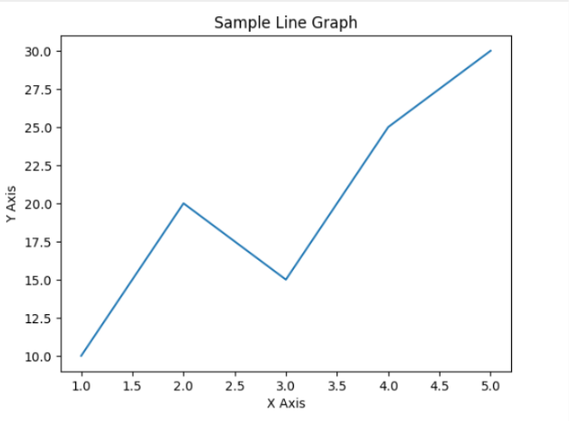

Result:

EXPT NO:1B | FORMULA 1 DRIVER STANDINGS DATA ANALYSIS USING PYTHON

AIM:
To perform Exploratory Data Analysis (EDA) on the Driver Standings dataset by examining its structure, dimensions, data types, statistical characteristics, missing values, driver performance, finishing-position distributions, correlations among numerical attributes, and exporting the dataset into different file formats.

PROCEDURE:
- Import the required libraries such as Pandas, OS, and Matplotlib.
- Load the Driver Standings CSV dataset using Pandas.
- Display the dataset shape, column names, and data types.
- Display the first five and last five records.
- Generate descriptive statistical information for numerical attributes.
- Identify the number of missing values in each column.
- Find the number of unique drivers and races represented in the dataset.
- Analyze the distribution of finishing positions.
- Find the top 10 driver IDs based on maximum points.
- Find the top 10 driver IDs based on maximum wins.
- Generate the correlation matrix for numerical attributes.
- Export the dataset into CSV, Excel, and JSON formats.
- Display a confirmation message after successful file creation.

CODE:
import os
import pandas as pd
import matplotlib.pyplot as plt

# Load dataset
file_path = "driver_standings(1).csv"
df = pd.read_csv(file_path)
print("Dataset loaded successfully!")

# First and last 5 records
print("\nFirst 5 rows:")
display(df.head())
print("\nLast 5 rows:")
display(df.tail())

# Dataset information
print("\nDataset Shape:", df.shape)
print("\nColumn Names:")
print(df.columns.tolist())
print("\nDataset Information:")
df.info()

# Descriptive statistics
print("\nDescriptive Statistics:")
display(df.describe())

CODE (CONTINUED):
# Missing values
print("\nMissing Values:")
display(df.isnull().sum())

# Unique drivers and races
print("\nUnique Drivers:", df["driverId"].nunique())
print("Unique Races:", df["raceId"].nunique())

# Position distribution
print("\nFinishing Position Distribution:")
display(df["position"].value_counts().sort_index().head(15))

# Top 10 drivers by maximum points
top_points = df.groupby("driverId")["points"].max().sort_values(ascending=False).head(10)
print("\nTop 10 Driver IDs by Maximum Points:")
display(top_points)

# Top 10 drivers by maximum wins
top_wins = df.groupby("driverId")["wins"].max().sort_values(ascending=False).head(10)
print("\nTop 10 Driver IDs by Maximum Wins:")
display(top_wins)

# Correlation matrix
print("\nCorrelation Matrix:")
display(df.corr(numeric_only=True))

# Export files
df.to_csv("driver_standings_analysis.csv", index=False)
df.to_excel("driver_standings_analysis.xlsx", index=False)
df.to_json("driver_standings_analysis.json", orient="records", indent=4)
print("\nCSV, Excel and JSON files created successfully.")

OUTPUT:
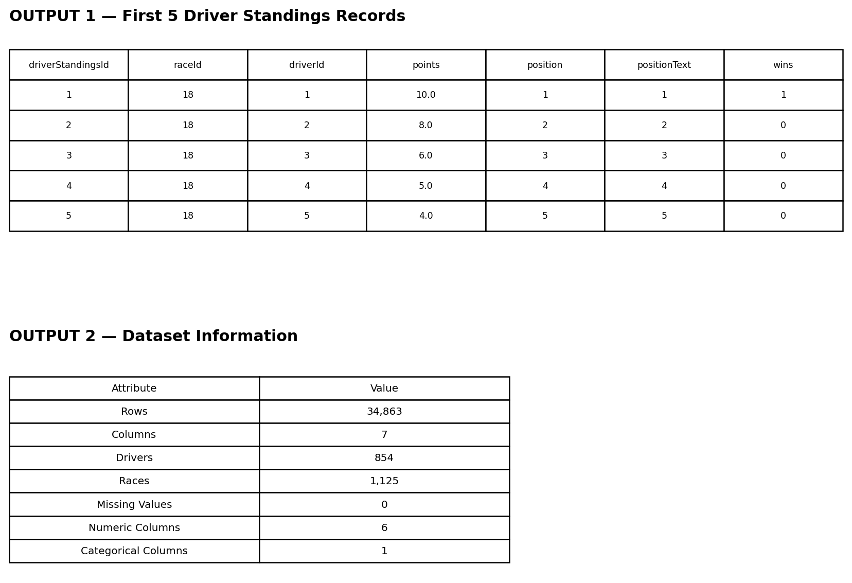

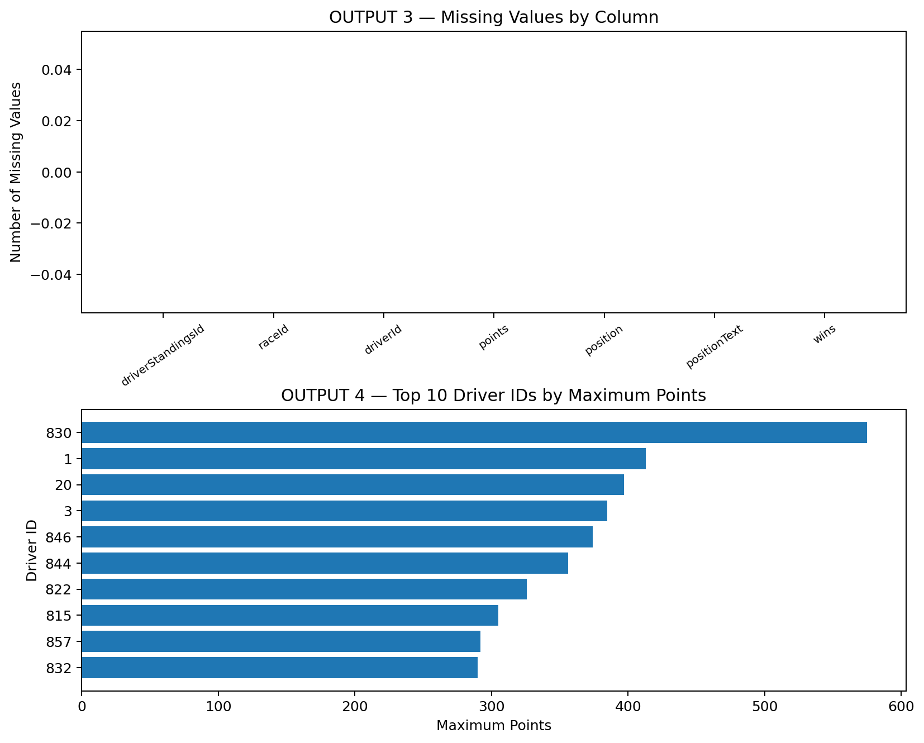
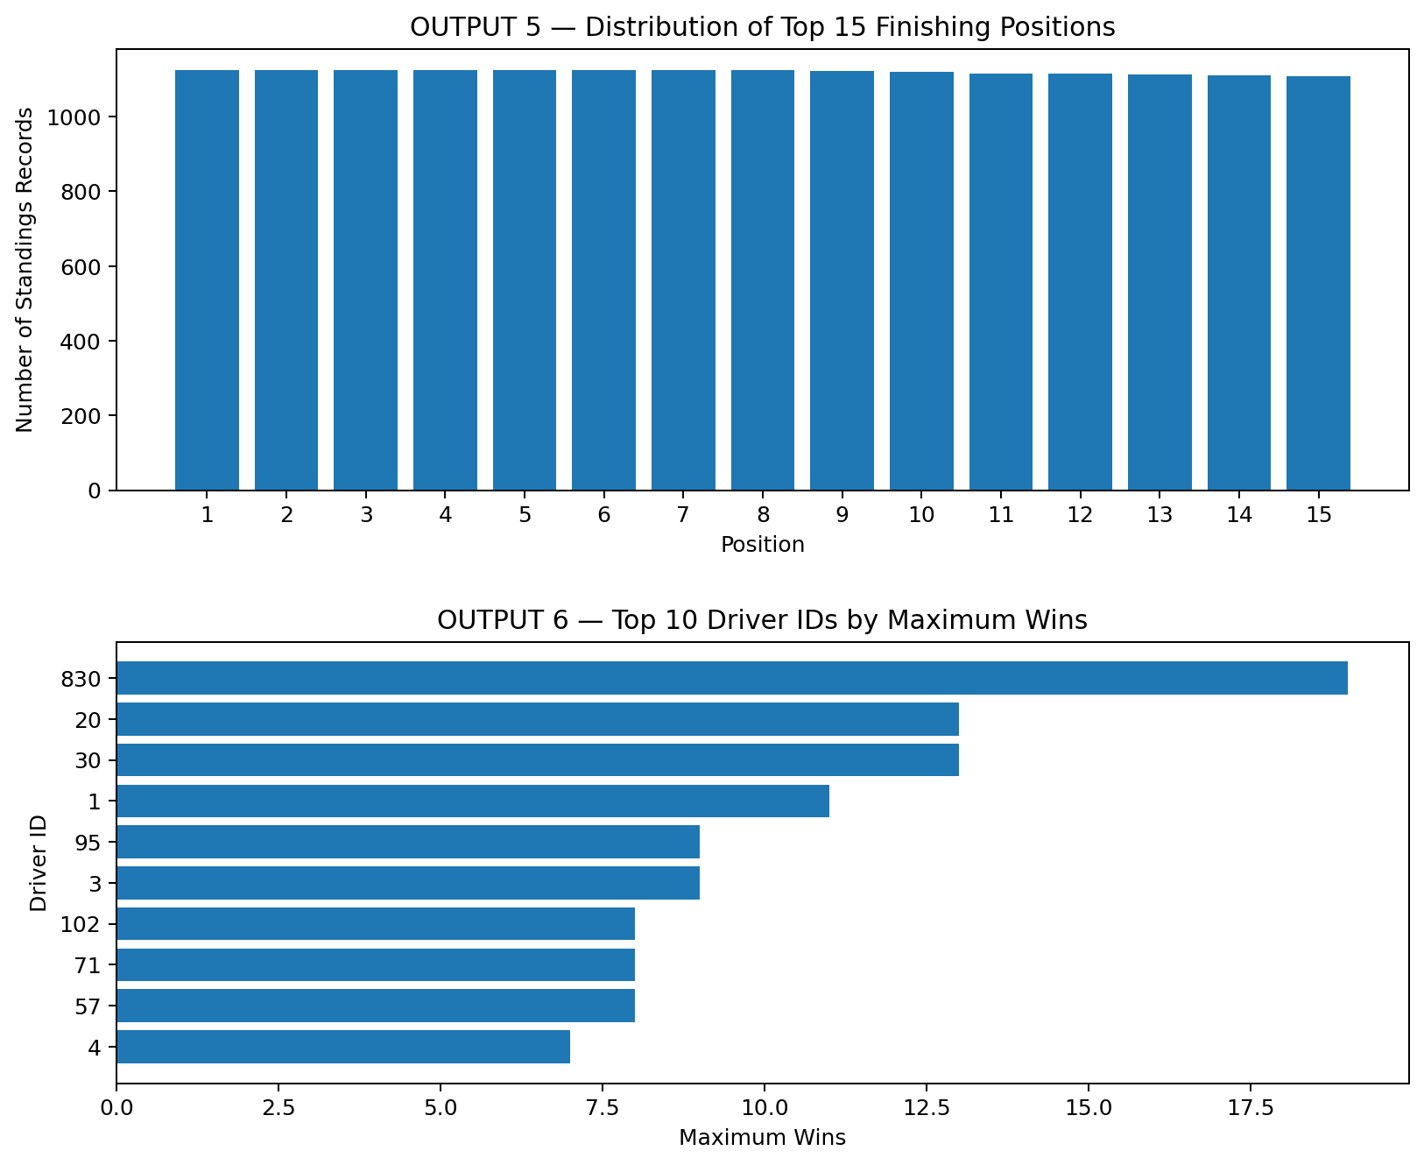

Analysis completed successfully!
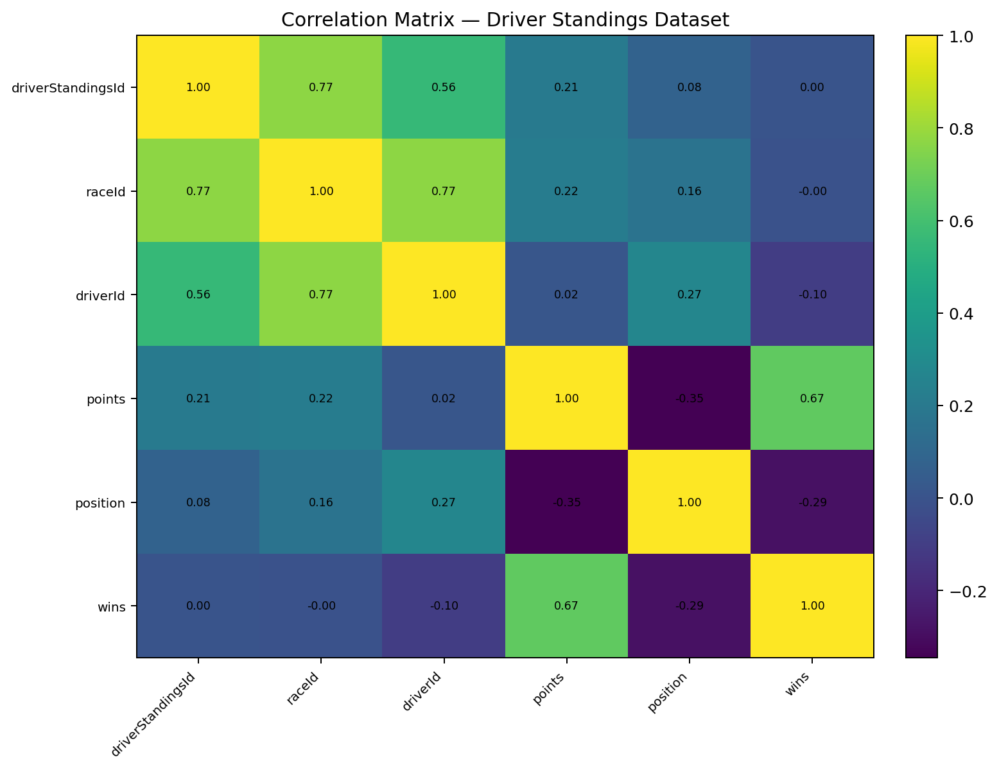

Result:
The Driver Standings dataset was successfully loaded and analyzed. The dataset contains 34,863 records and 7 columns, with no missing values. The analysis covered descriptive statistics, driver and race counts, finishing-position distribution, driver points and wins, and correlations among numerical attributes. The processed dataset was also exported successfully in CSV, Excel, and JSON formats.

